## EraserTool

Progress(27/02/19)

Screenshot 1

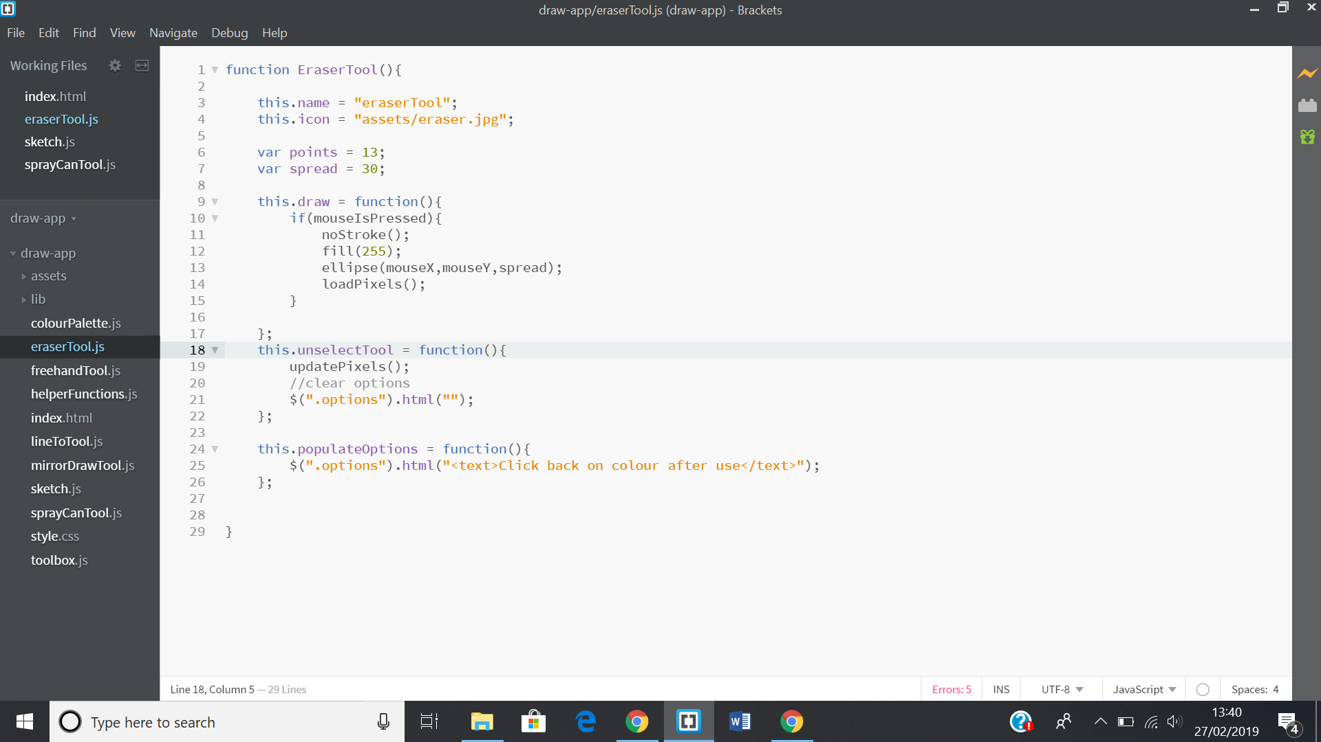

This is the code so far for the eraser tool.

Screenshot 2

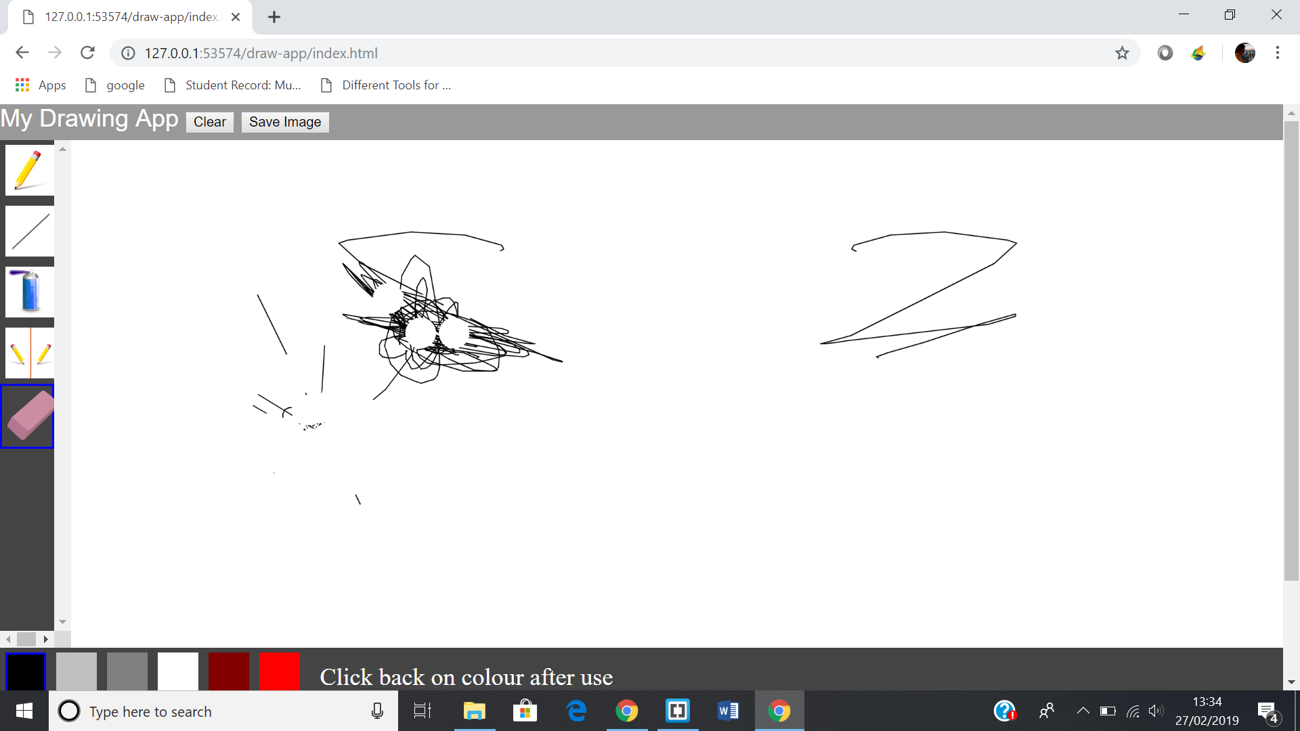

This is a quick demo of how it works. The only problem i have with it so far is that after you are done using it, you have to click back onto a colour to start drawing. That is why i put a message next to the colour palette.

05/03/19

Screenshot 3

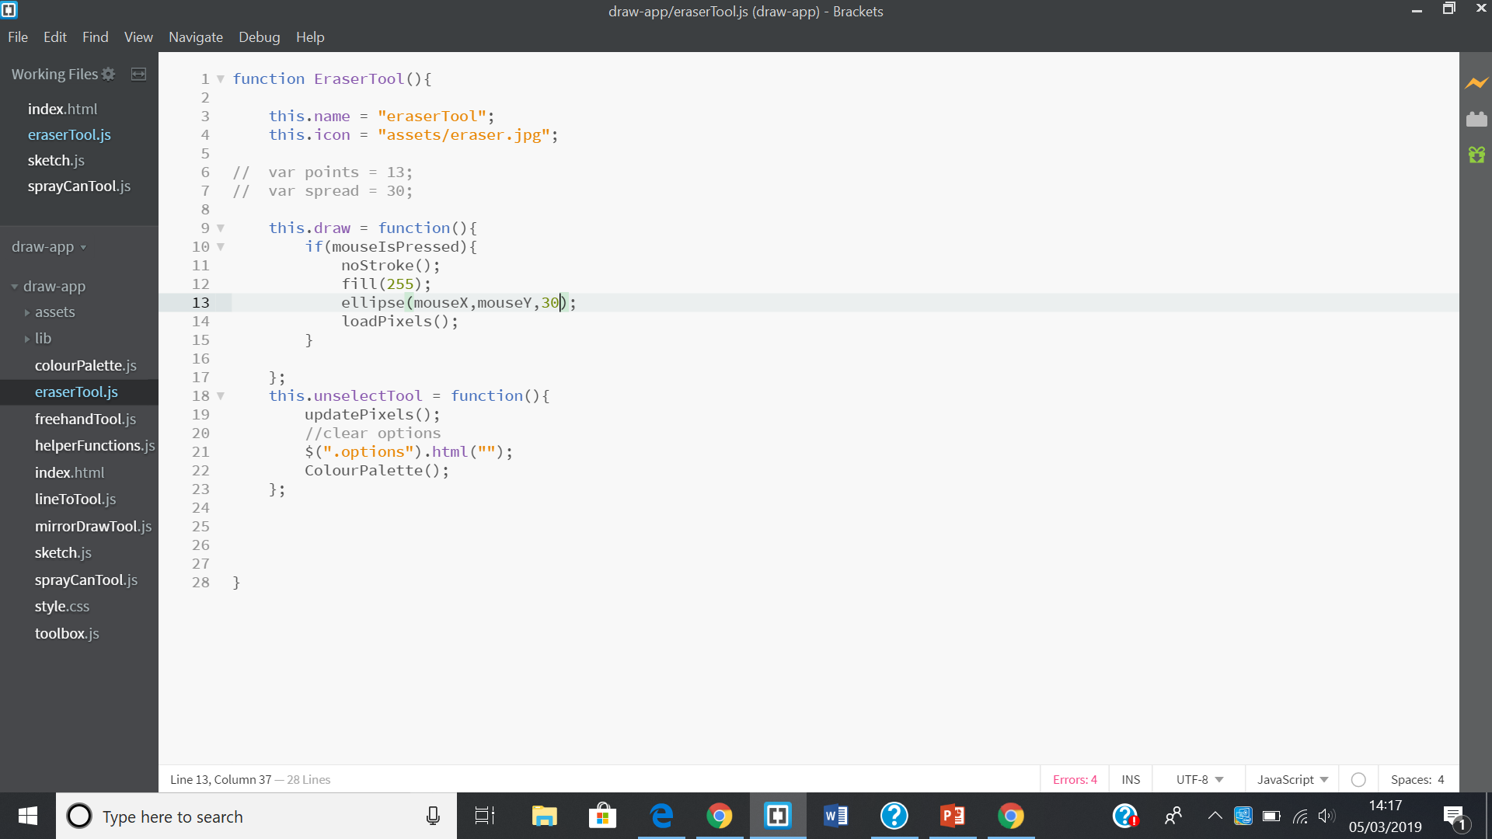

I have now fixed the issue by calling the function ColourPalette in the unselectTool function which selects as a colour when you select another tool on the sidebar(lines 18-23).

20/03/19

Screenshot 4

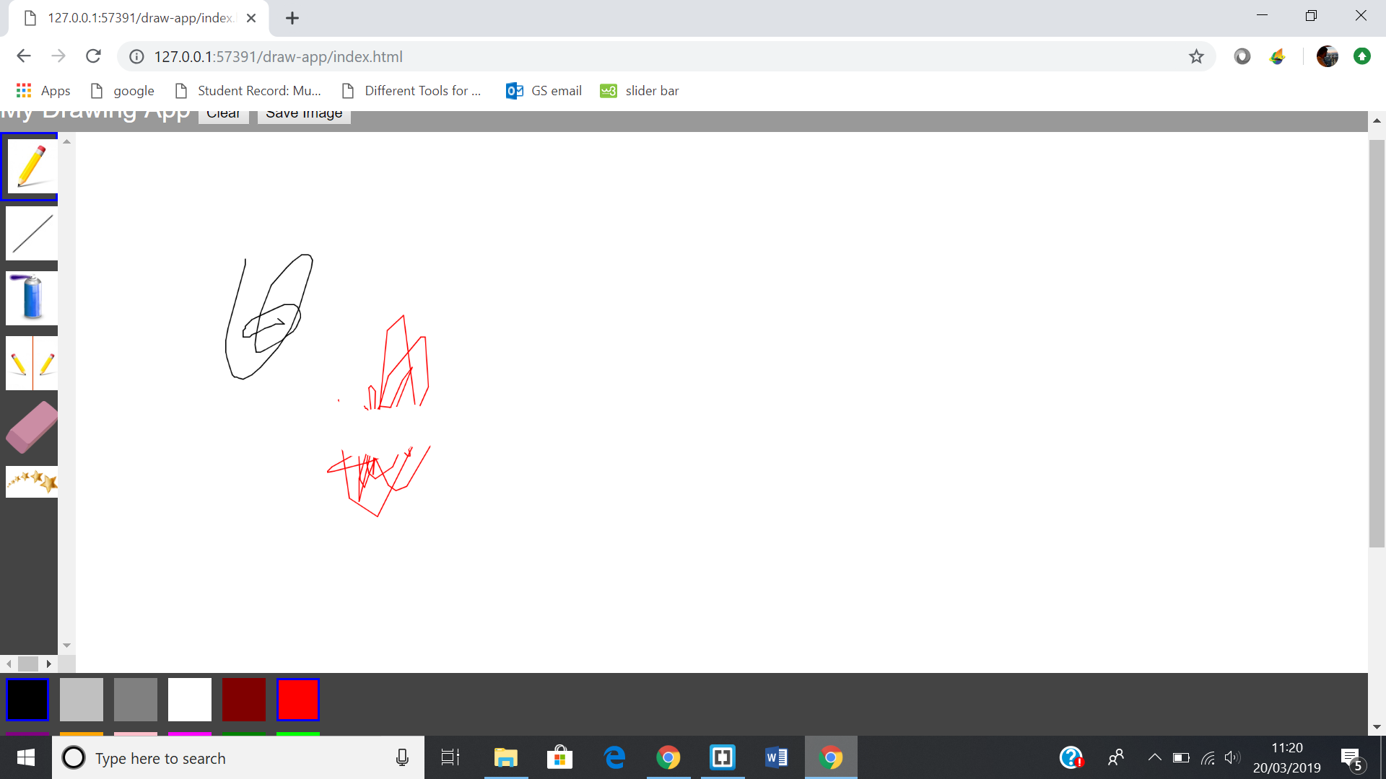

There is a bug with my eraser tool. Whenever i deselect the eraser tool, the current colour changes to black but the the previous colour is still highlighted along with black. Look at the colour palette(bottom left corner). I will attempt to do the spirograph or blur tool.

26/04/19

I still have not fixed the issue with the colourPalette problem.

(26/04/19)

Screenshot 5

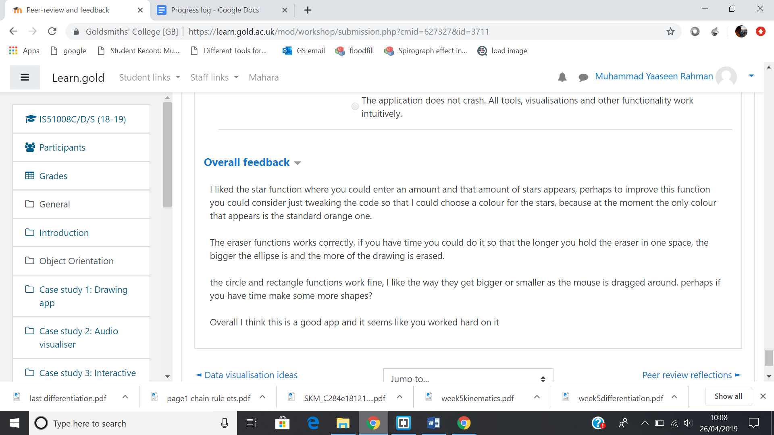

I was asked to make improvements to the eraserTool by allowing the user to change the size of the eraser.

Screenshot 6

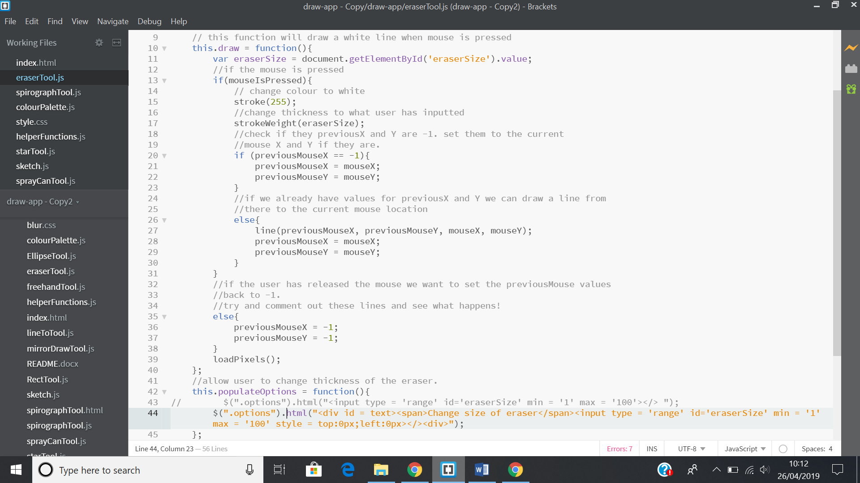

First i had to change the way i paint over the drawing. I copied the freehand tool but changed the thickness(line 17). I put in a slider for them to change the size(line 44)

Screenshot 7

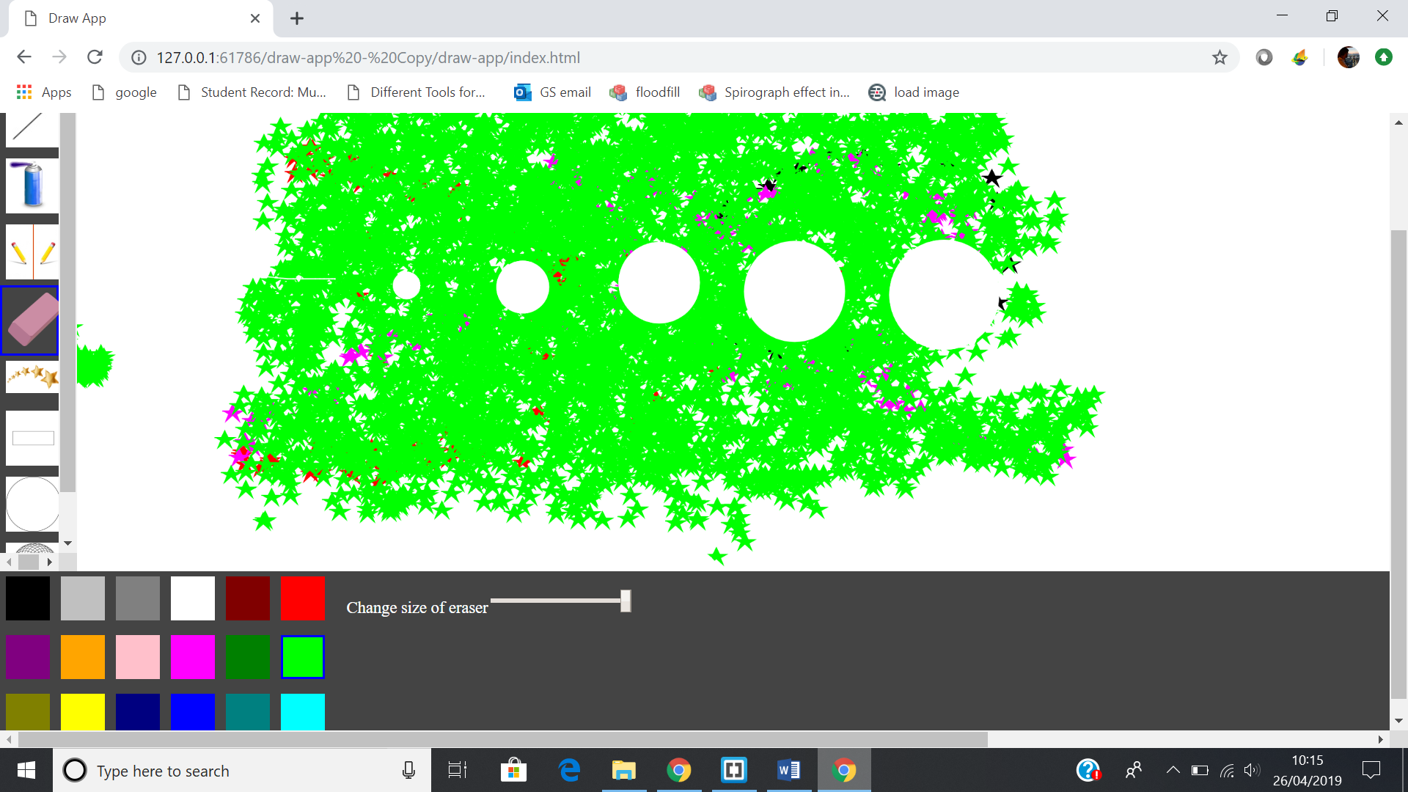

Demo of how it works. Left of the slider is the smallest and the right side is the biggest size the eraser can have.

## StarTool

05/03/19

Screenshot 8

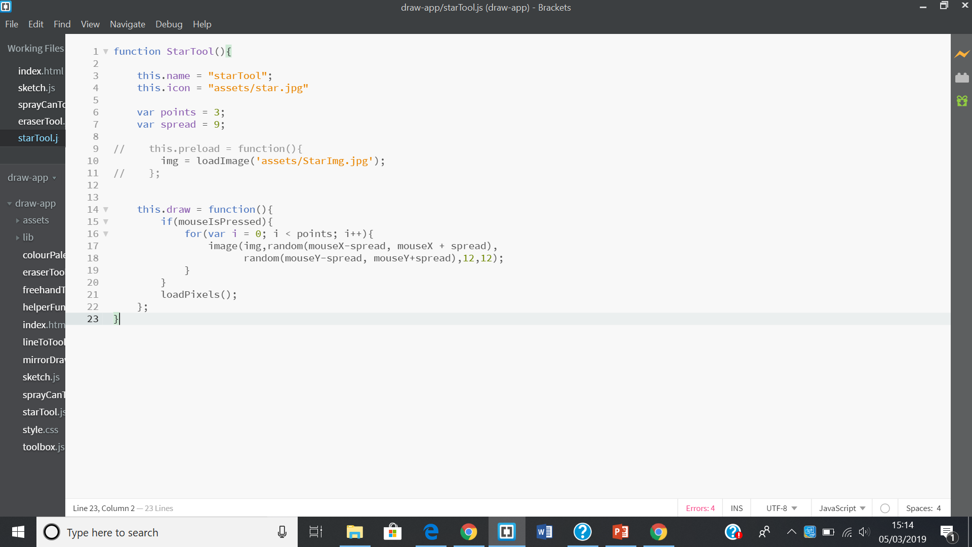

This is the star tool. Instead of drawing a star, I used an image of a star instead. It work the same way as the spray can.

Screenshot 9

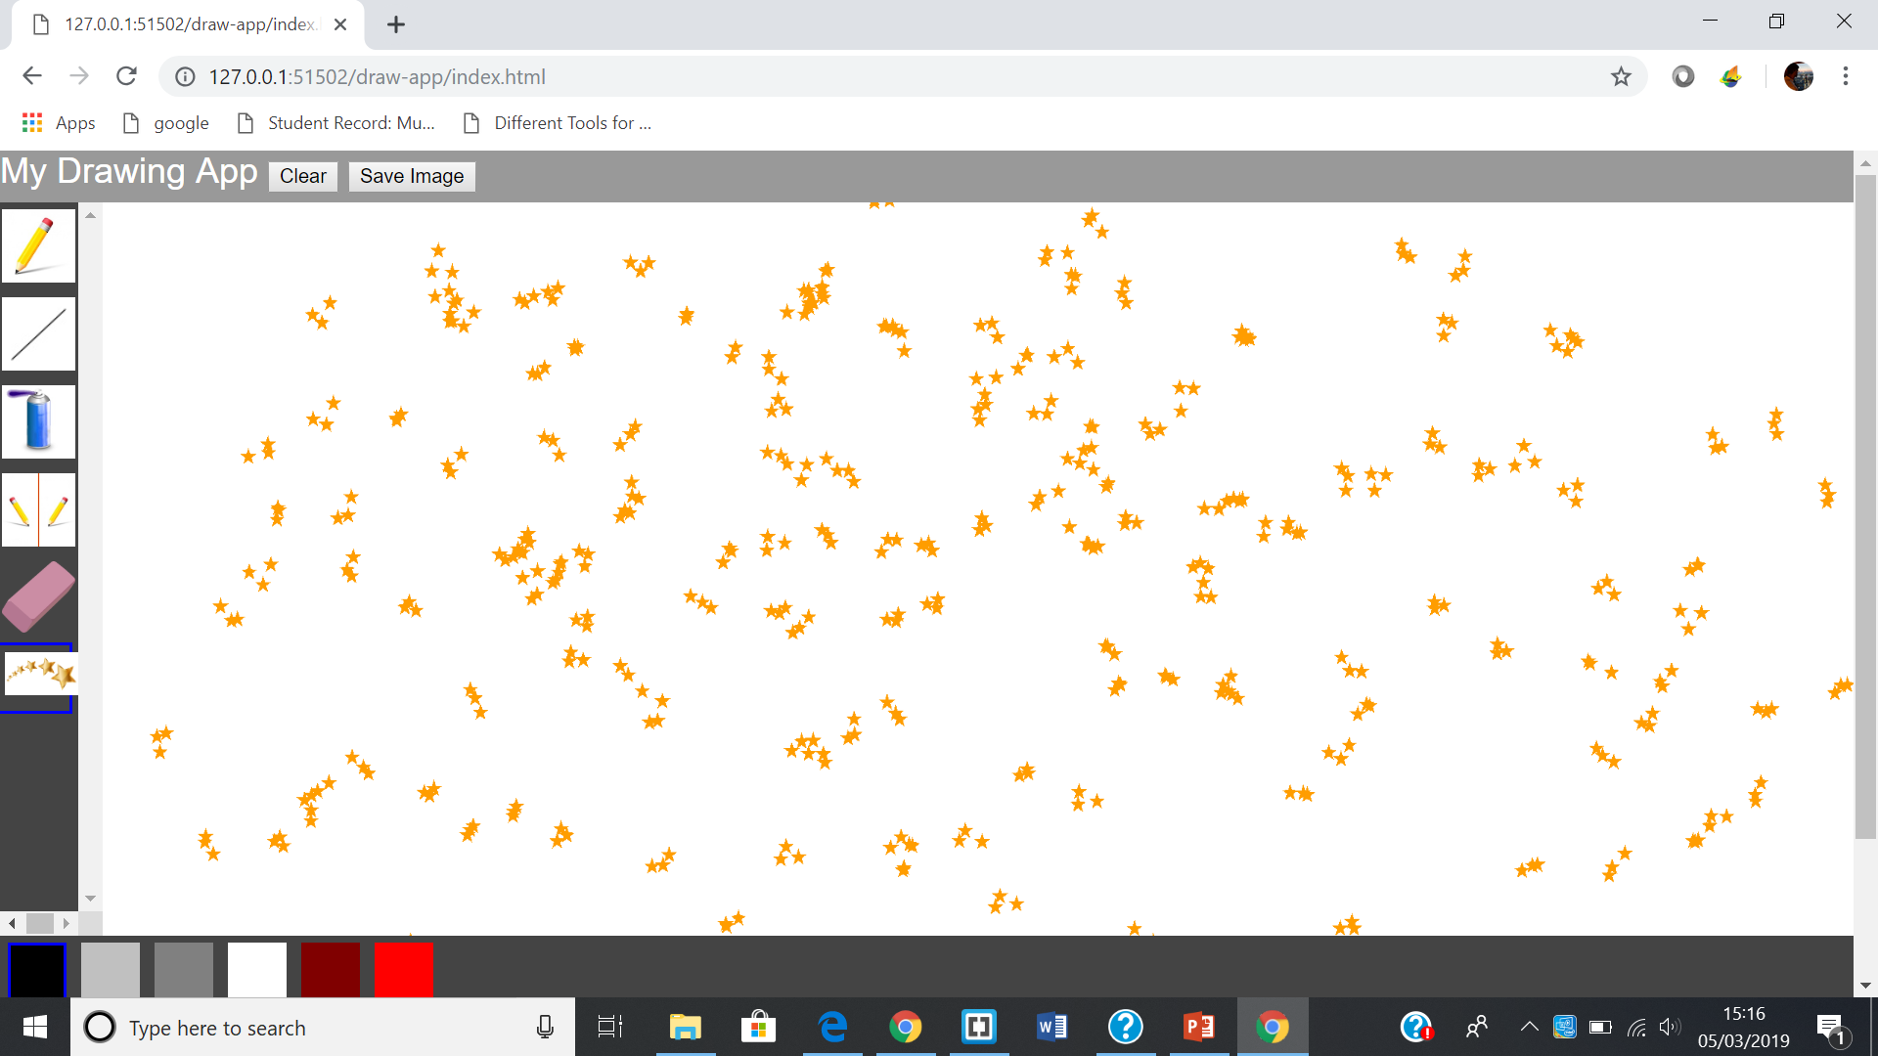

This is a quick demo of how it works. Next i will allow the user to enter how many stars they would like to add.

12/03/19

Screenshot 10

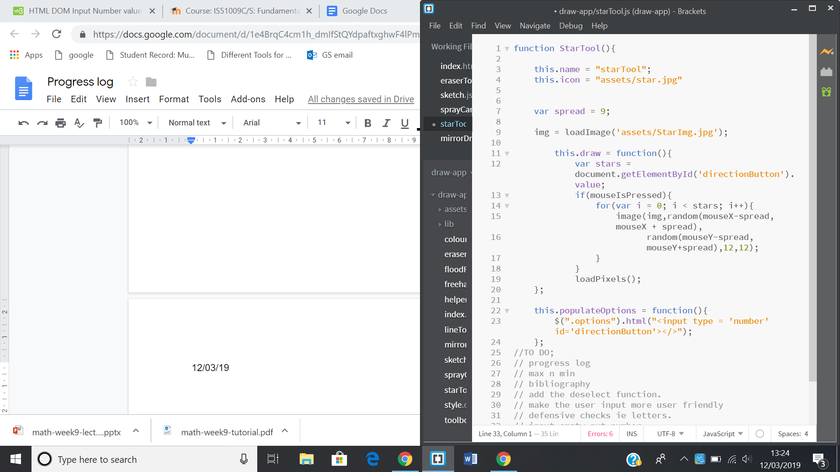

Lines 22-24 allow the user to give an input. Line 12 saves the user input in stars to that it can be used later in the for loop. I need to put a restriction on the maximum and minimum number of stars a user can have and need to check if they type letters instead of numbers.

Screenshot 11

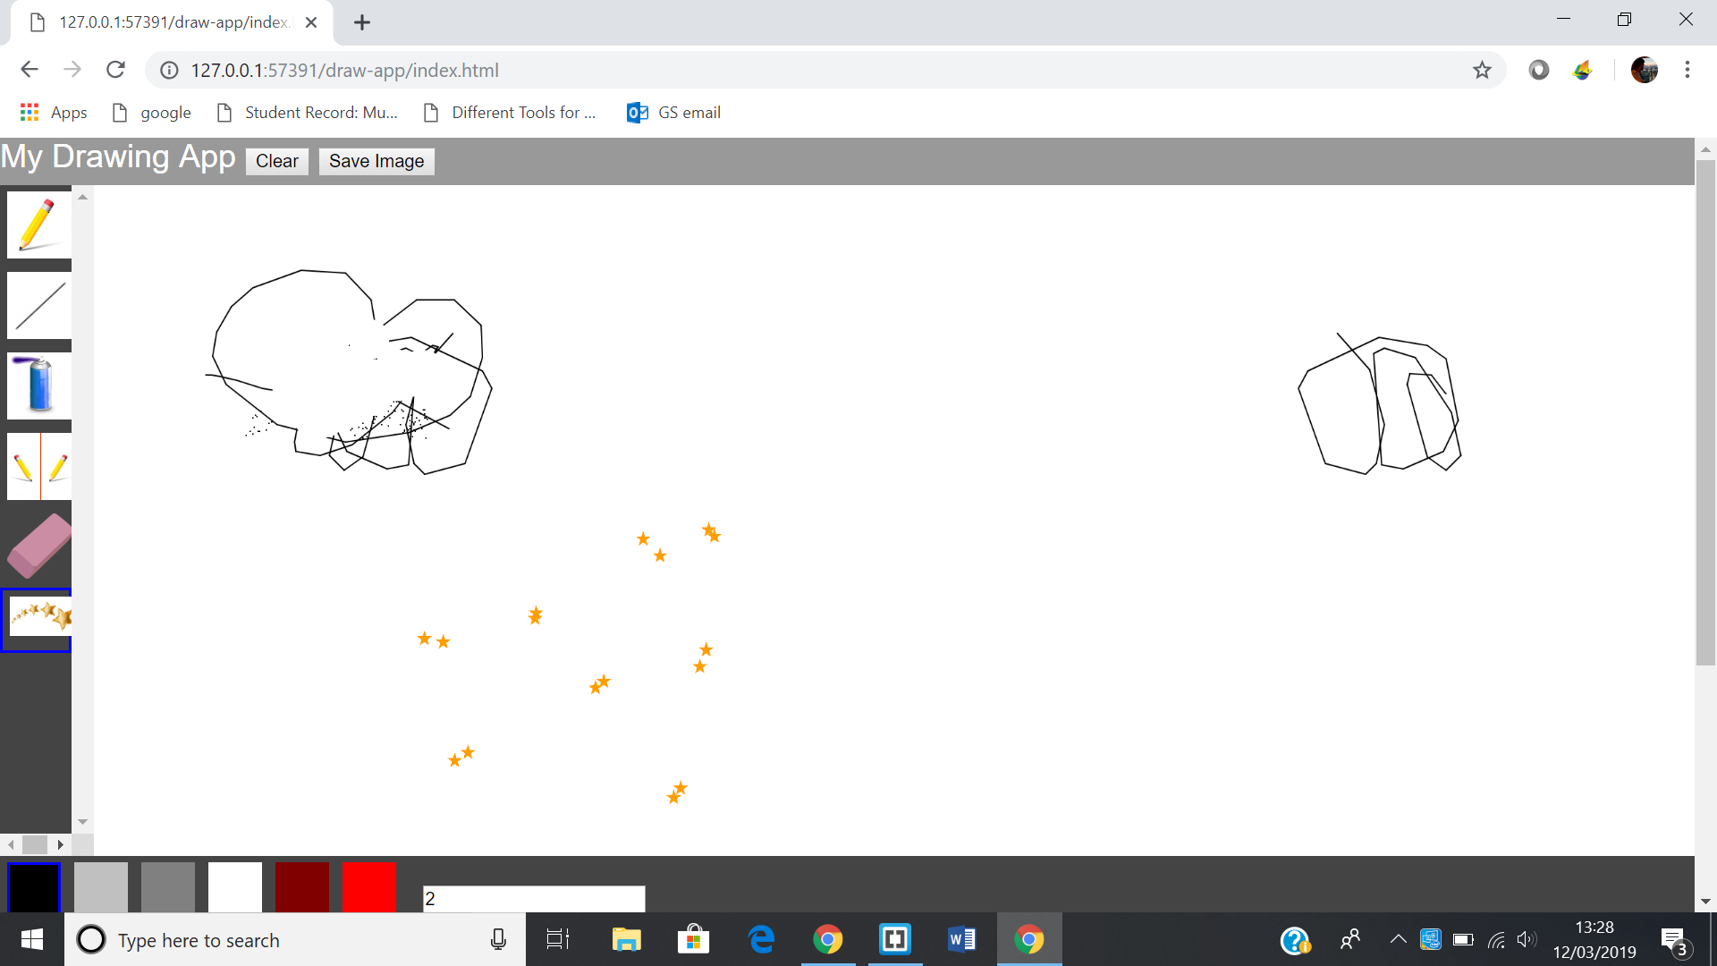

At the bottom near the colour palette you type the number of stars. I used 2 so 2 stars are created every time i click the mouse. But it creates stars very quickly meaning sometimes stars bunch up together. It allows allows the letter e to be accepted so i need to fix that. It allows allows decimals

(19/03/19)

Screenshot 12

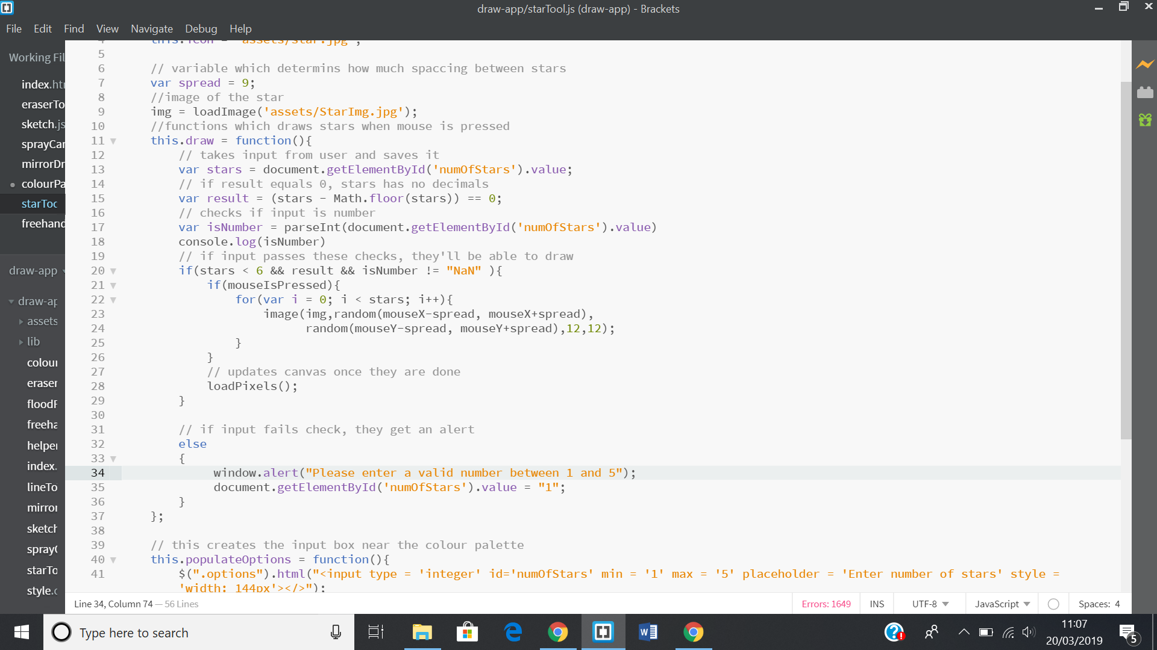

I added some defensive coding to check if the input is a decimal,letter or a number higher than 5. If yes, then give an alert to the user.

Screenshot 13

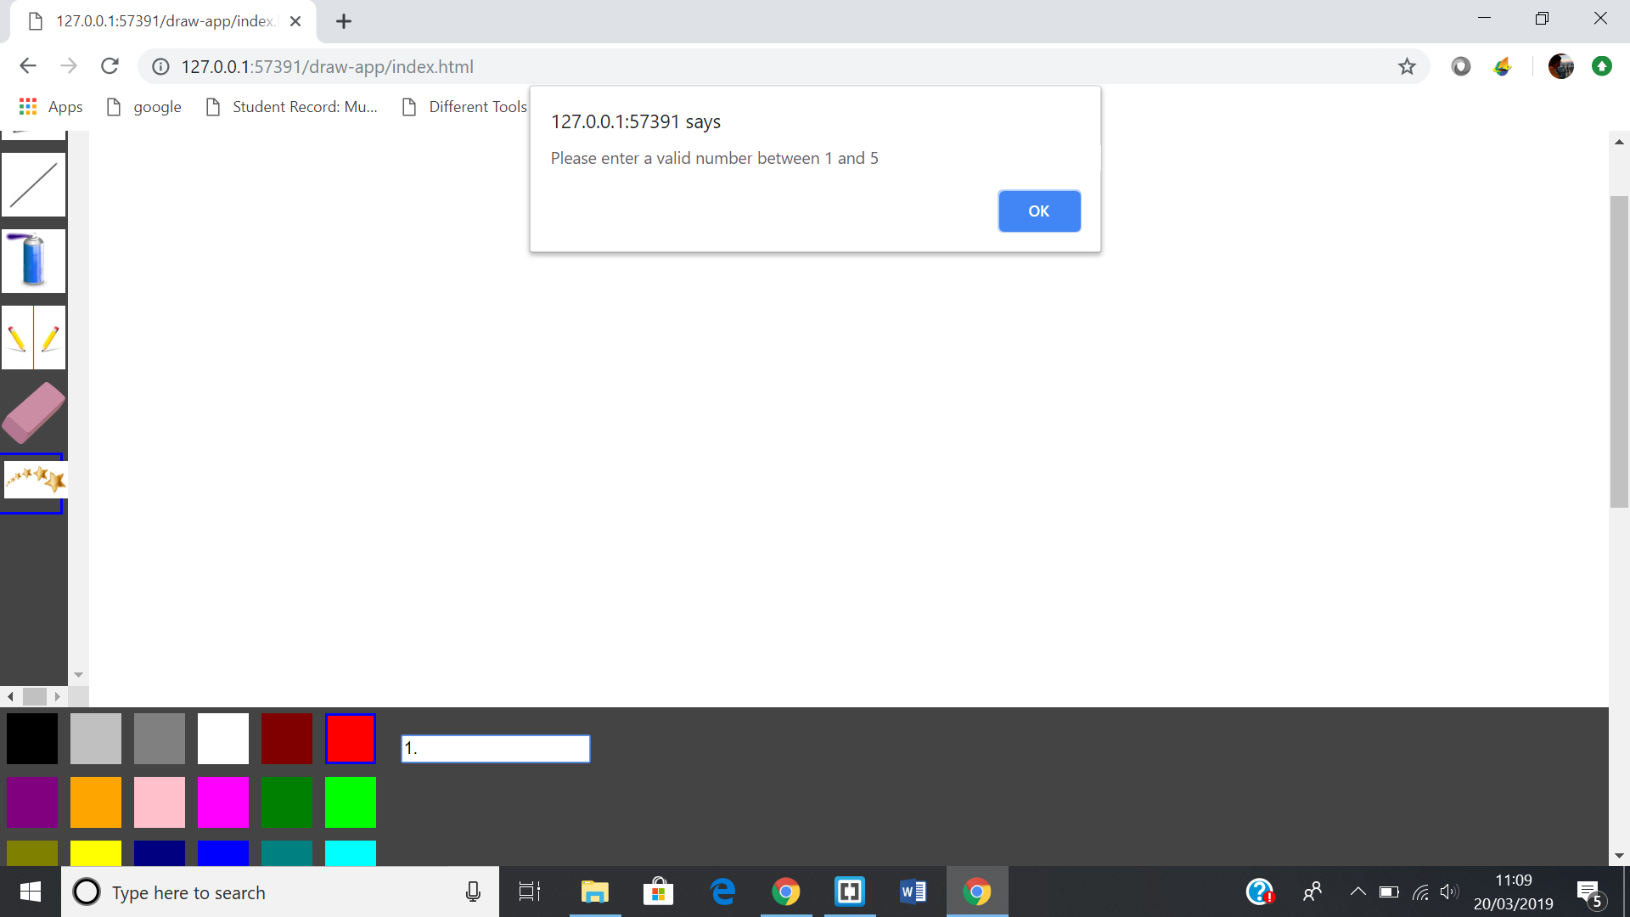

Quick demo of how it works. Star tool works perfectly now with no errors or bugs.

(26/04/19)

Screenshot 14

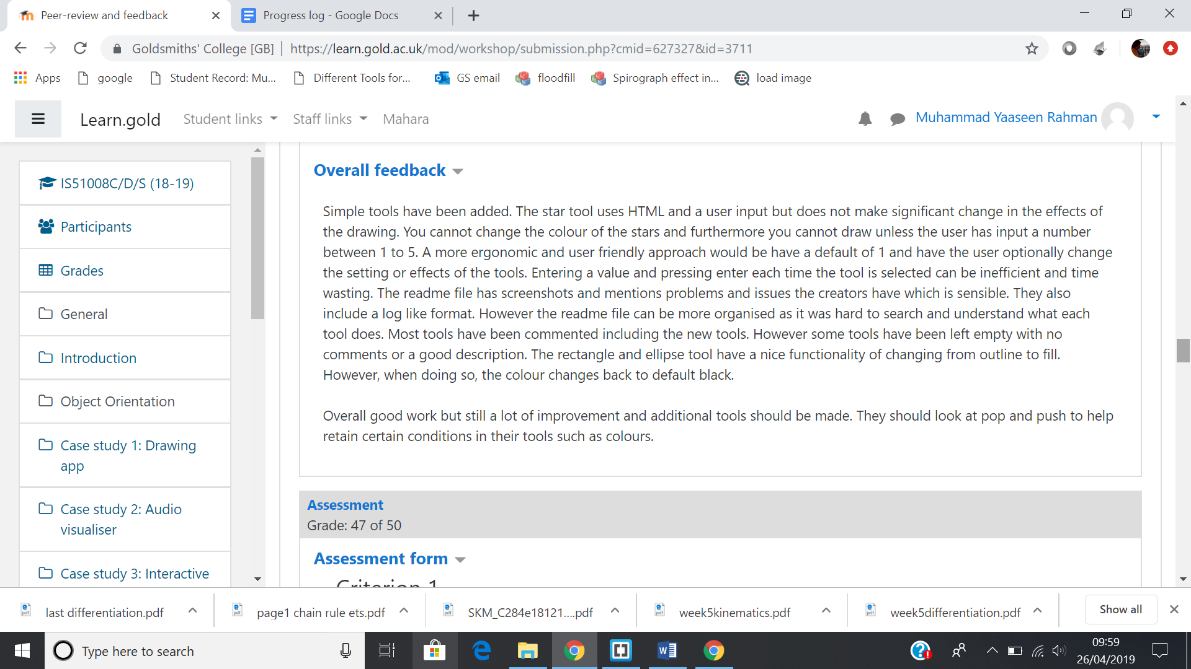

The feedback has asked me to add improvements to the starTool by allowing the user to change colours and make the Number of stars = 1 upon selecting the tool.

Screenshot 15

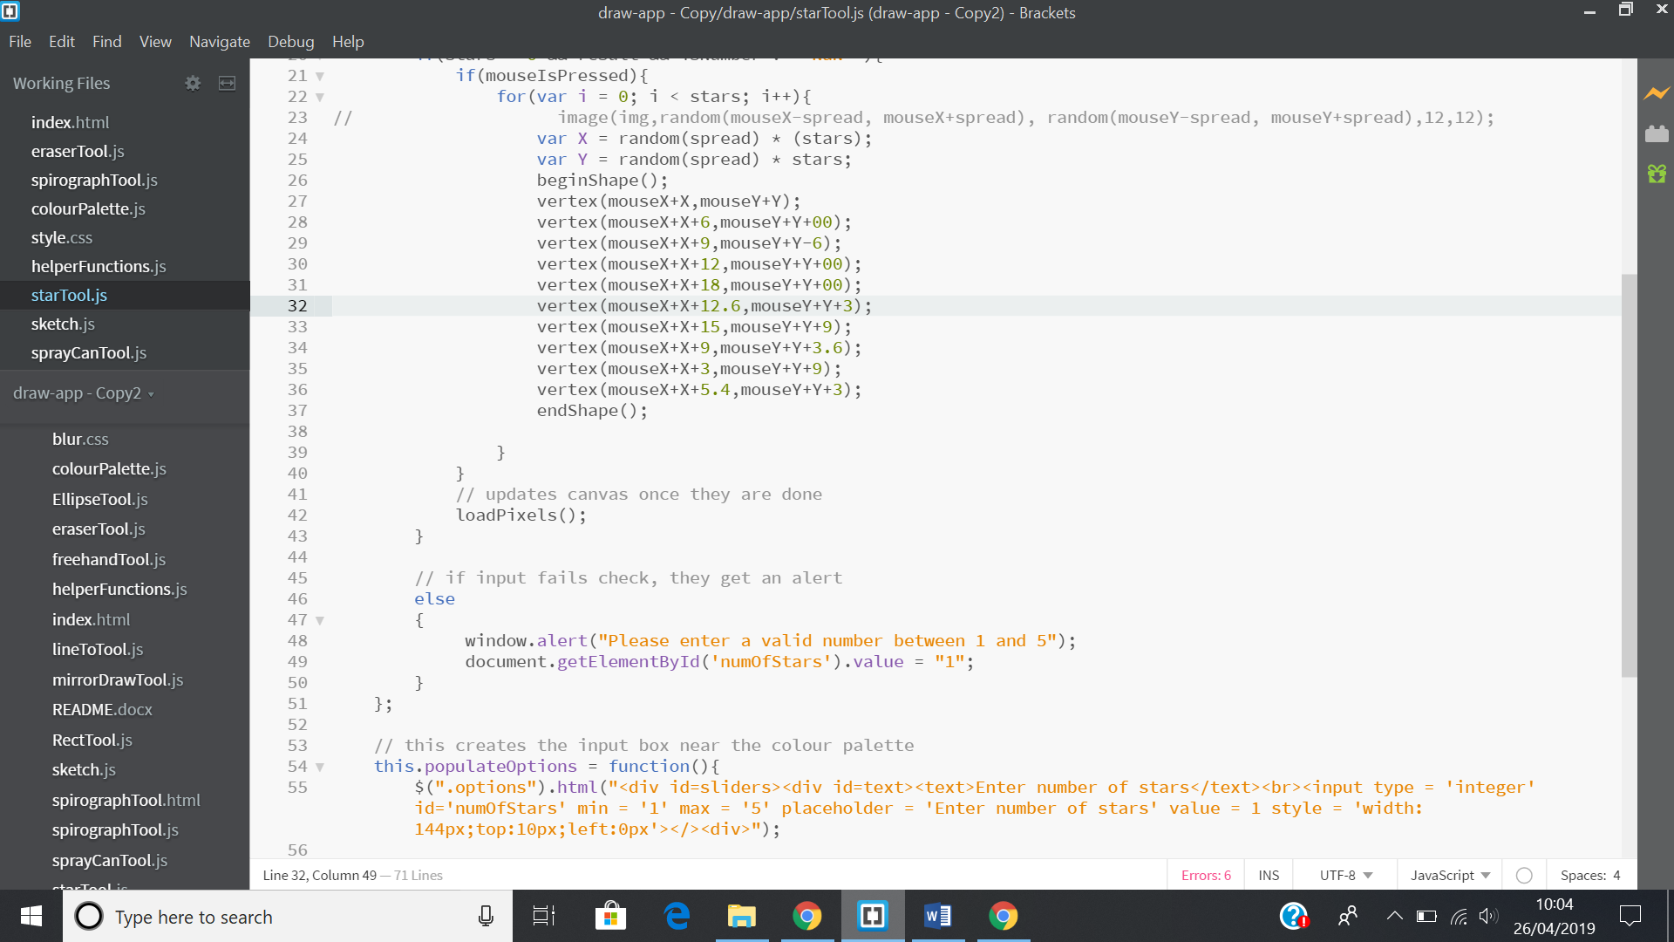

To do this, i had to create my own star because i used an image of a star and you could not change the colour of it.(line24-37). I also changed the value of variable star to 1(line55).

Screenshot 16

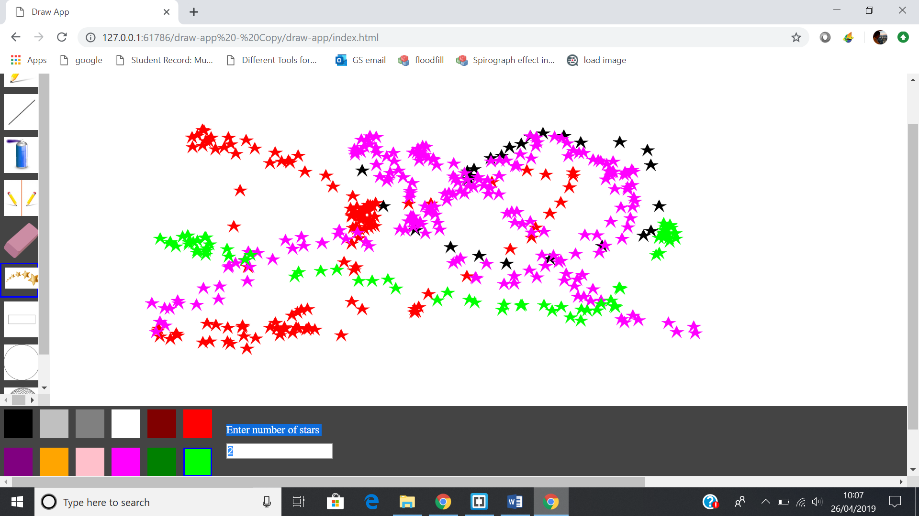

Demo of how the star works. Also, I do not call colourPalette so there was no problem with selecting colours after you have selected another tool like the eraser. It says on the colour you have selected when you were using the StarTool.

## SpirographTool

(12/04/19)

Screenshot 17

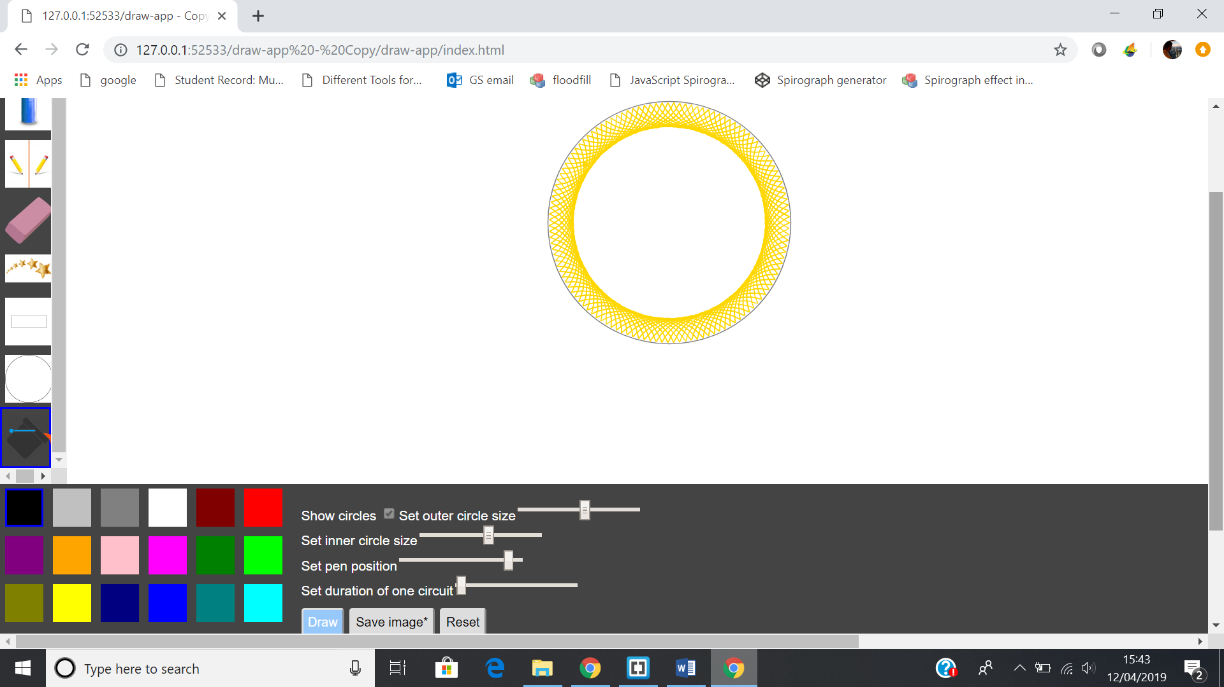

This is the spirograph tool. It allows you create your own spirograph. I got the code from the internet but changed so it works with my code.

Screenshot 18

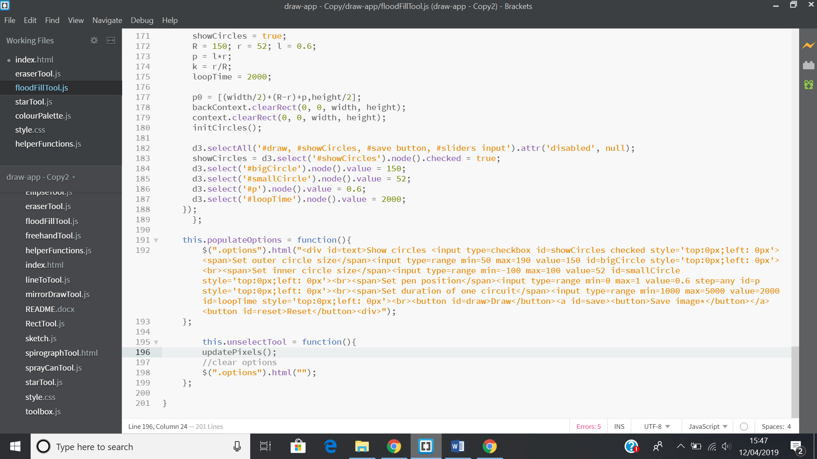

I had to put the html code in the populate option function so that when you select another tool, the sliders that allow you to design the spirograph should disappear.

Screenshot 19

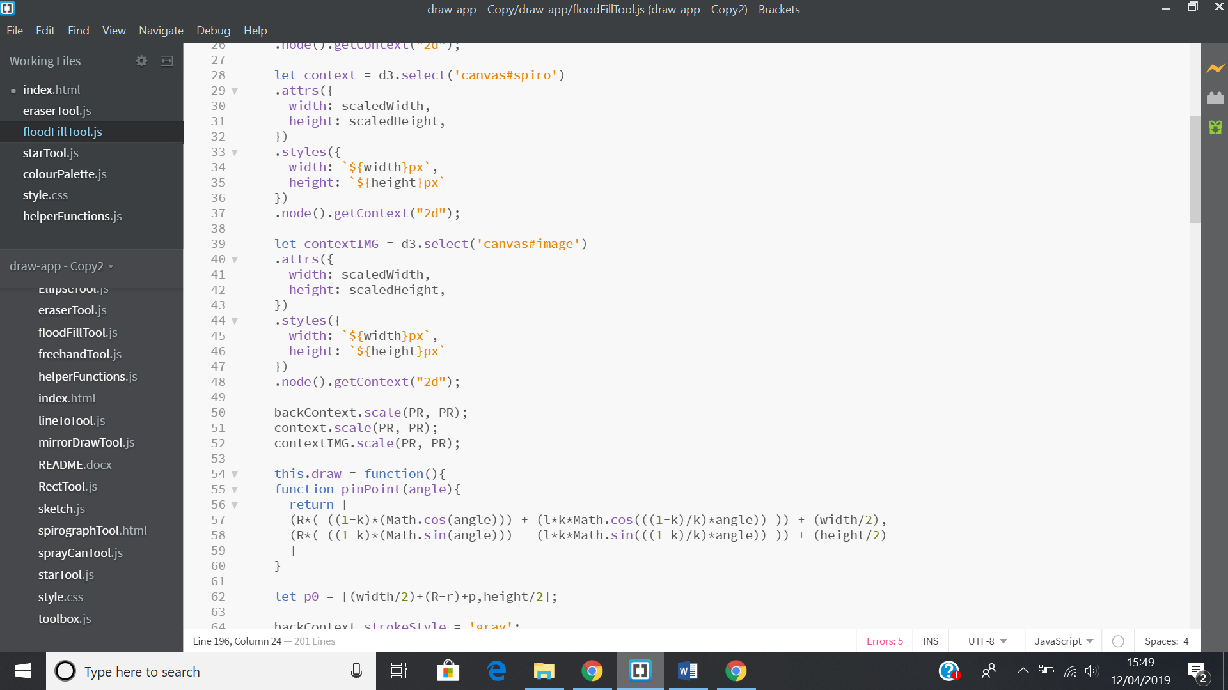

I had to separate the variables from the drawing code otherwise the spirograph will keep resetting.

The only problems i have with spirograph tool is that the clear and save button does not work on it. I click clear, the spirograph remains and when i press save the spirograph is not there and it creates useless space to the left.

Screenshot 20

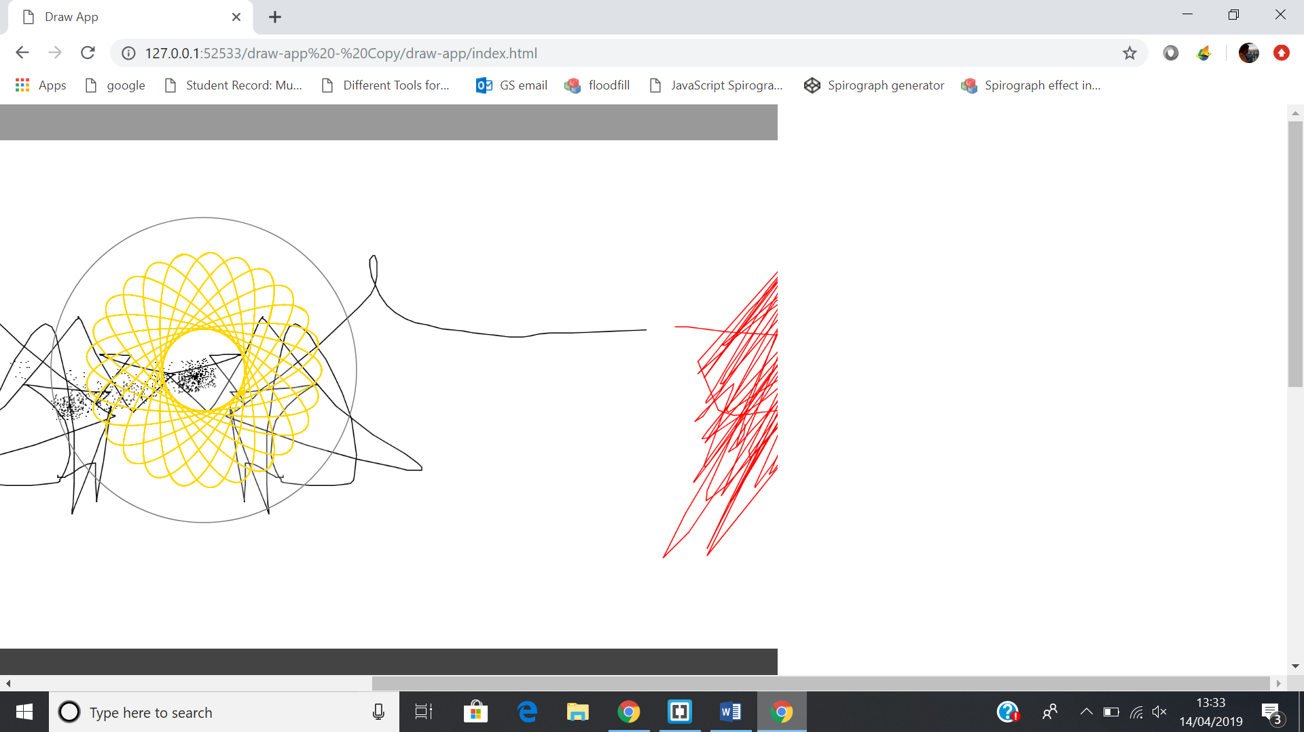

Screenshot 21

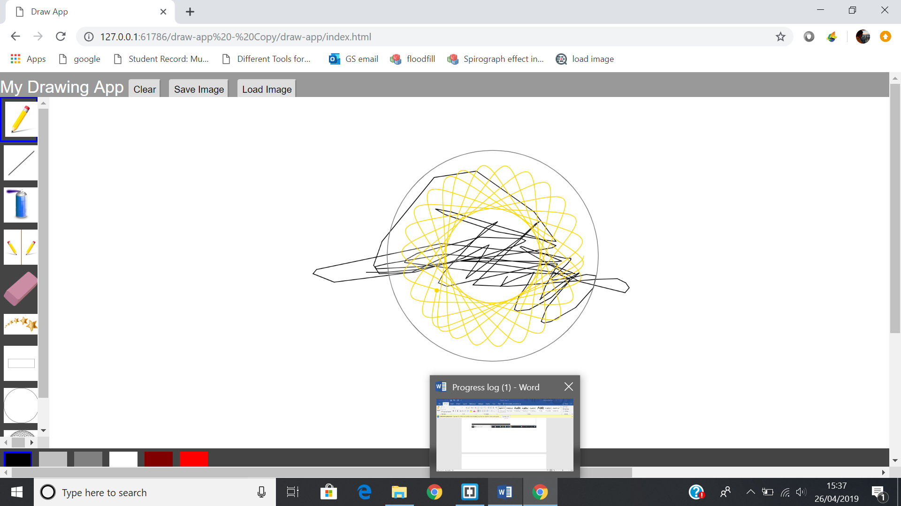

This is the image of the canvas but when the user presses save only the black lines will pop up.

Screenshot 22

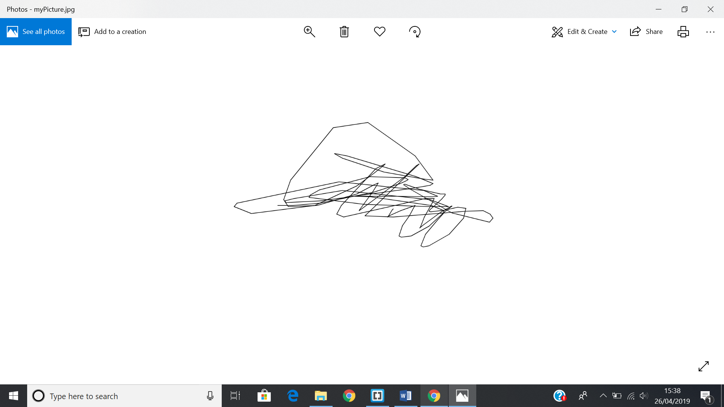

The spirograph is not there.